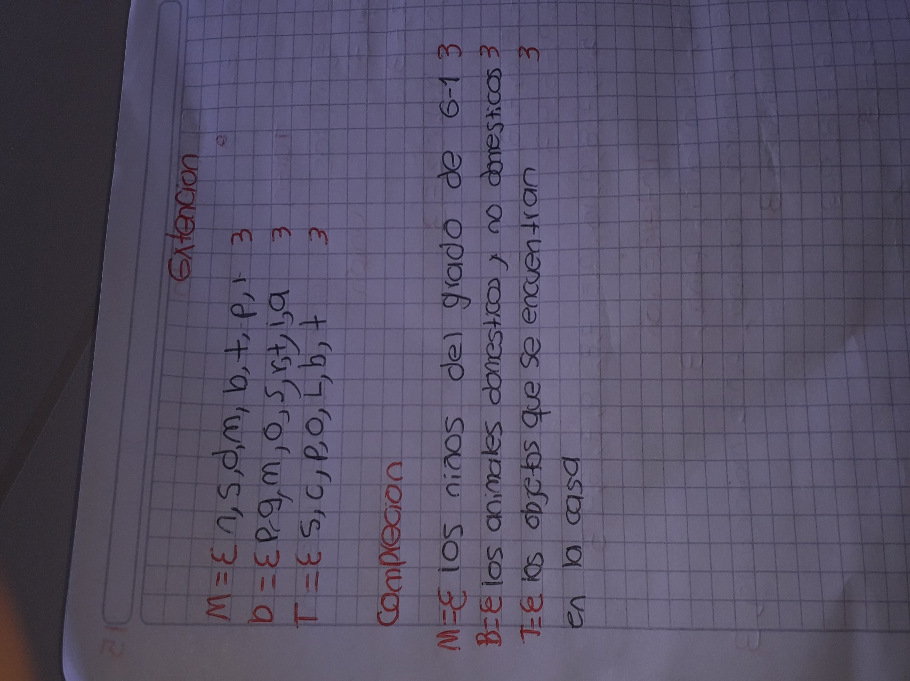JULIAN ANDRES MORALES LIZARAZO 6-1 05/05/2020